Phillip Pascual
005869470
CSE 572
Spring 2019

Lab 2

1. DESC lists the column definitions for the specified table, view, or synonym, or specifications for the specified function or procedure.

2. ‘dictionary’ is the table that we are accessing. It is the list of all tables in the database.

3. DESC dictionary lists the following:
-name of each column (table name, null, and comments)
-description of if each column is empty
-the datatype and size of each table. In this case both columns are varchar2’s of size 30 and
4000 respectively

4. SELECT * FROM dict; results in a list of all tables in the database. There are currently 835 entries displayed, which represent the 835 separate tables in the database.

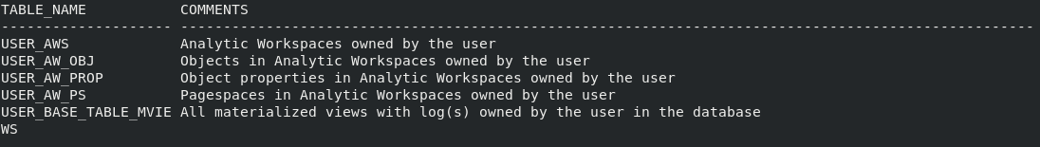

5. An alternative command to execute a SQL script file is @scriptfile

6. There are 835 records in the dictionary.

7.
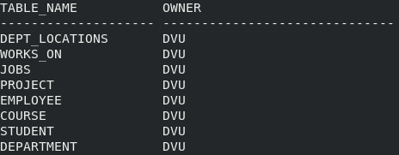

This is the list of all tables that are owned by user DVU.

8.
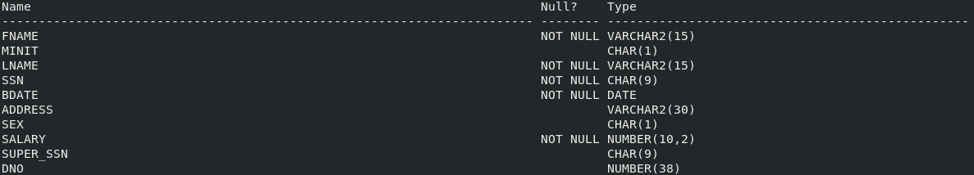
This is the description of all the attributes of the ‘Employee’ entity. It describes the name of each column, lists whether there is a null or not null constraint, and the data type and size of each column.

9.
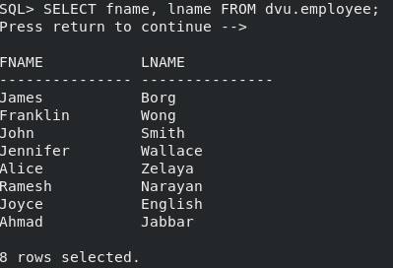

10. SELECT returns a result set of records from one or more tables. The syntax is SELECT <columns> FROM <table/tables>. The column can singular, multiple columns, or all columns in the table using the * operator.
